Password Cracking Report – John the Ripper & Networkwalks Tools
W3-PM-FINAL | Cybersecurity | Networkwalks
Field | Details
Pentester name | MYRA ALI KHAN
Program / Batch | B083D – Networkwalks Cybersecurity Internship
Date of testing | 3 October 2026
Modules completed | W3-PM1 (Password cracking with John the Ripper); W3-PM2 (Password cracking with Networkwalks web tools)
Target file | My Locked PDF1.pdf – the training capture-the-flag file supplied by Networkwalks
Written authorization | Networkwalks course materials; testing limited to the supplied training file on my own laptop
Phase covered | Phase 3: Exploitation – password recovery (training file only)

1. Liability Disclaimer
This exercise was performed only on the training file supplied by Networkwalks, on my own laptop. Password cracking tools must only be used on files and systems you own or are authorized to test. Cracking passwords on files or accounts belonging to others is illegal in most countries.
These materials are for education and research only. The purpose is to understand how weak passwords are recovered, so that stronger ones can be chosen.

2. Introduction
This report covers Week 3 of my Networkwalks Cybersecurity Internship: recovering the password of a protected PDF (My Locked PDF1.pdf) using two methods that reach the same result.
When a PDF is locked, the password is not stored in the file. Instead the file holds a hash: a scrambled value derived from the password. Cracking works in two steps. First, a crackable hash (starting with $pdf$) is extracted from the file. Second, a cracking tool hashes candidate words from a wordlist and compares each to the target, stopping when one matches.
Module W3-PM1 does this with John the Ripper, the standard command-line cracker. Module W3-PM2 does the same with the browser-based Networkwalks Hash Calculator and Password Cracker. Both recovered the password password1.

3. Tools Used
Tool | Role | Used in
John the Ripper (1.9.0-jumbo-1, Win64) | Command-line password cracker; hashes wordlist candidates and compares to the target | W3-PM1
pdf2john | Extracts the crackable $pdf$ hash from a PDF | W3-PM1 (hash obtained via the Networkwalks Hash Calculator, as Perl was not installed)
Networkwalks Hash Calculator | Browser tool that extracts the $pdf$ hash from a locked PDF | W3-PM1 and W3-PM2
Networkwalks Password Cracker | Browser tool that runs a dictionary attack against the $pdf$ hash | W3-PM2
Windows Command Prompt | Running John and inspecting the hash file | W3-PM1
Note: the lab lists the Johnny GUI as an optional front-end for John the Ripper. I used John directly from the command line, which runs the same engine and is better evidence of the underlying workflow.

4. Activities Performed
Both modules targeted the same file, My Locked PDF1.pdf (renamed locked.pdf for convenience), and both recovered the password password1.

4.1 Password Cracking with John the Ripper (W3-PM1)
- Downloaded the John the Ripper 1.9.0-jumbo-1 Win64 binaries from openwall.com and extracted them. The cracker (john) and the extractor scripts are in the run folder.
- Copied the locked PDF into the run folder and opened a command prompt there.
- Extracted the crackable hash. The build shipped only pdf2john.pl (Perl) and Perl was not installed, so I obtained the identical $pdf$ hash using the Networkwalks Hash Calculator and saved it to hash1.txt. The hash begins:
$pdf$4*4*128*-1060*1*16*55d1a5c14175da449753199e44971d32*32*777fd021a7f3c5ae598c0c6495c7f76e...
- Ran the cracker against the hash file:
john hash1.txt
john --show hash1.txt
- John recovered the password. john --show reported locked.pdf:password1.
- Opened the PDF with password1; it displayed the Congratulations – you have captured your 1st flag page, confirming the crack.

4.2 Password Cracking with Networkwalks Tools (W3-PM2)
- Opened the Networkwalks Hash Calculator (networkwalks.com/hash-calculator), chose the PDF tab, and uploaded locked.pdf. The tool extracted the same $pdf$ hash and I copied it.
- Opened the Networkwalks Password Cracker (networkwalks.com/password-cracker), pasted the hash, and kept the built-in 100-password wordlist.
- Clicked Start Cracking. The tool tried each word in turn and stopped at [+] MATCH password1, showing Password cracked successfully.
- Opened the PDF with password1 and reached the same flag page.
The browser tools are a no-install version of the same dictionary-attack idea John the Ripper uses: extract the hash, run a wordlist against it, stop on a match.

5. Findings & Risk Analysis
The PDF password was password1, recovered almost instantly by both tools because it is a common dictionary word on every basic wordlist.
# | Finding | Evidence | Why it matters
1 | Weak, common password | Recovered from a 100-word list on the first run | A password on a common wordlist offers almost no protection; it is found in seconds
2 | Crackable hash extractable from the file | pdf2john / Hash Calculator produced a $pdf$ hash | Anyone who gets the file can extract the hash offline and attack it at their own pace, with no lockout
3 | Offline attack, no rate limiting | Both tools ran locally with no restriction | Unlike a login form, an offline file gives an attacker unlimited guesses
The weakness here is the password choice, not the PDF format itself. A long, random password on the same file would not be found by a dictionary attack.

6. Recommendations
- Use long, random passwords. A 12+ character mix of upper, lower, digits and symbols defeats dictionary and most brute-force attacks.
- Never reuse common words or patterns such as password1, 123456 or names; these are the first entries in every wordlist.
- Use a password manager to generate and store unique passwords, so strong ones are practical to use.
- Protect the file itself, not just with a password: limit who can obtain it, since an attacker needs the file to run an offline attack.
- For sensitive documents, prefer strong encryption (for example AES-256) and share passwords through a separate, secure channel.

7. Conclusion
In Week 3 I recovered a protected PDF's password two ways: with John the Ripper from the command line, and with the Networkwalks browser tools. Both followed the same logic, extract the hash then run a wordlist against it, and both returned password1 almost immediately.
The exercise showed concretely why password strength matters. A common word offers no real protection against an offline attack, where the attacker has the file and unlimited guesses. It also showed the difference between a tool (John the Ripper, the engine) and a front-end (Johnny, or the Networkwalks web page): the cracking work is the same underneath.
All testing was limited to the training file supplied for this lab, on my own laptop.

8. Evidence Collected

W3-PM1 – John the Ripper
- Figure 1: type hash1.txt showing the $pdf$ hash, john hash1.txt running, john --show hash1.txt showing locked.pdf:password1

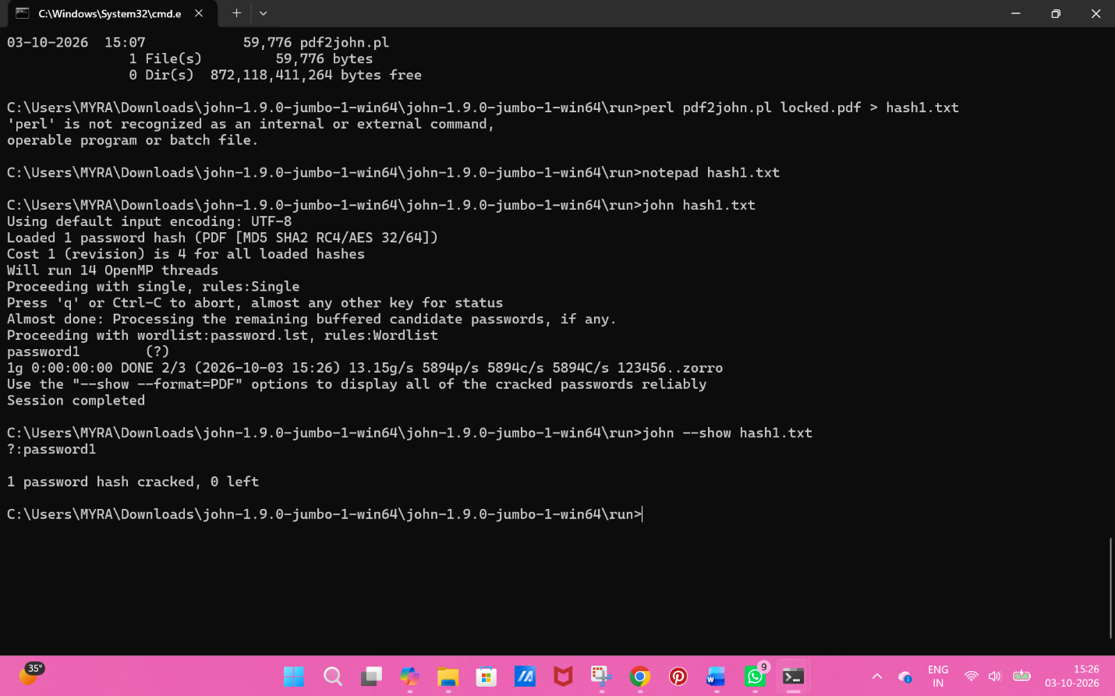
- Figure 2: the unlocked PDF flag page
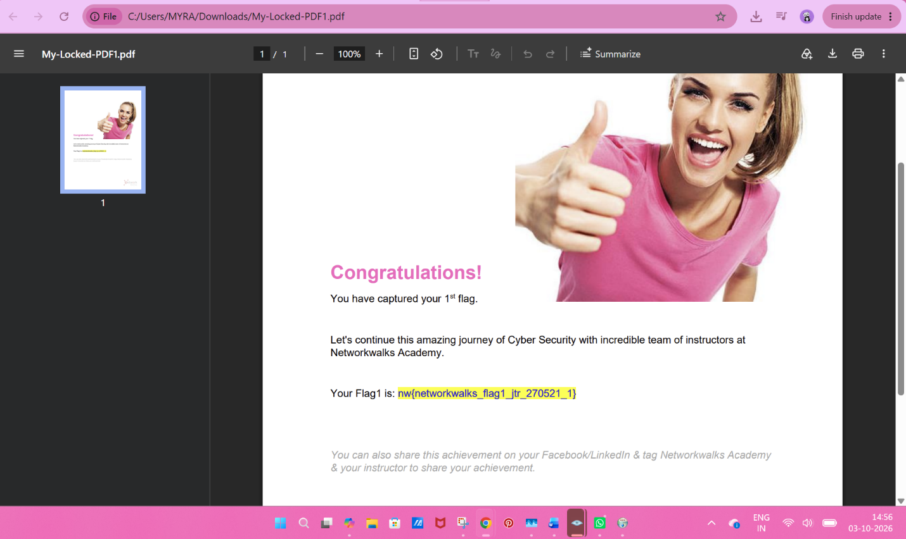
W3-PM2 – Networkwalks Tools
- Figure 3: Hash Calculator showing the extracted $pdf$ hash
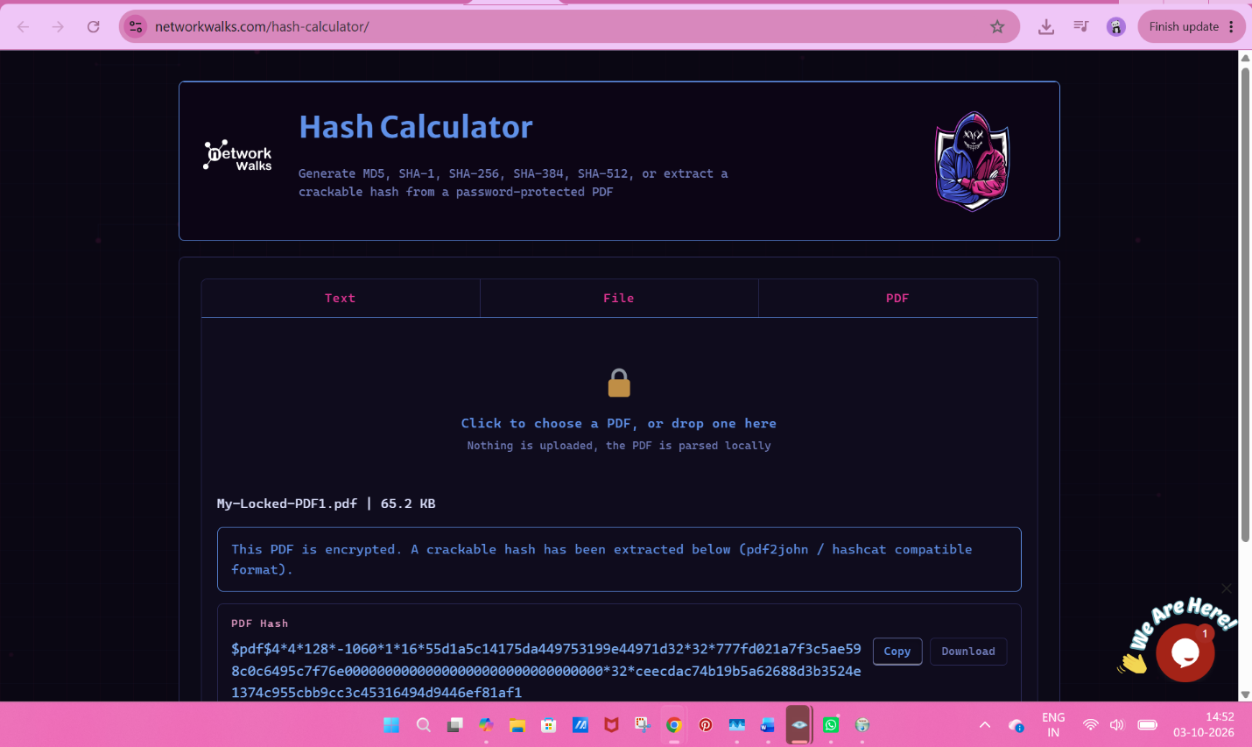

- Figure 4: Password Cracker showing MATCH password1
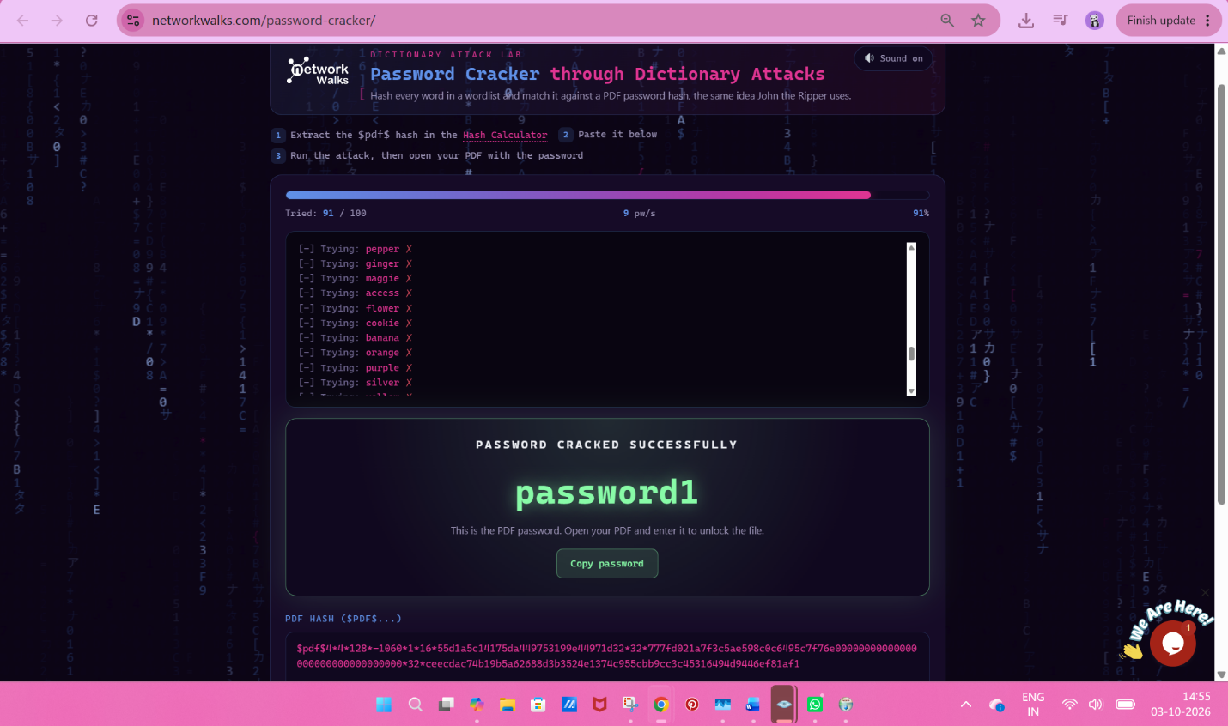

- ☐ Figure 5: the unlocked PDF flag page

